WIFI – MODULE - 4

1. Significance of the MAC Layer and Its Position in the OSI Model
The Medium Access Control (MAC) layer is a sublayer of the Data Link Layer (Layer 2) in the OSI model. It sits directly above the Physical layer (Layer 1) and below the Logical Link Control (LLC) sublayer.
Significance of the MAC Layer:
- Medium Access Control: The MAC layer governs how devices share and access the transmission medium, preventing collisions and ensuring fair access.
- Addressing: It assigns unique 48-bit hardware addresses (MAC addresses) to network interface cards, enabling device identification within a local network.
- Frame Delimitation: The MAC layer defines the start and end of data frames, ensuring the receiver correctly identifies individual frames.
- Error Detection: Using mechanisms like CRC (Cyclic Redundancy Check), the MAC layer detects errors introduced during transmission.
- Flow Control: It manages the pace of data transmission between sender and receiver to prevent buffer overflow.
- Channel Access Methods: Implements CSMA/CA (in Wi-Fi), CSMA/CD (in Ethernet), TDMA, FDMA, etc., to coordinate access among multiple stations.
Position in the OSI Model:
The OSI model has seven layers:
- Layer 7 – Application
- Layer 6 – Presentation
- Layer 5 – Session
- Layer 4 – Transport
- Layer 3 – Network
- Layer 2 – Data Link [LLC sublayer / MAC sublayer]
- Layer 1 – Physical
The MAC sublayer is the lower portion of Layer 2. It interfaces directly with the Physical layer and manages how the physical medium is accessed and used.

2. Frame Format of the 802.11 MAC Header
The IEEE 802.11 MAC frame consists of three main parts: MAC Header, Frame Body, and FCS. The MAC header contains the following fields:
- Frame Control (2 bytes): Contains subfields including Protocol Version (2 bits), Type (2 bits – Management/Control/Data), Subtype (4 bits), To DS, From DS, More Fragments, Retry, Power Management, More Data, Protected Frame, and Order. This field describes the frame type and transmission attributes.
- Duration/ID (2 bytes): Specifies the duration in microseconds for which the channel will be occupied, used for NAV (Network Allocation Vector) updates in virtual carrier sensing.
- Address 1 (6 bytes): Destination Address (DA) – the immediate receiver of the frame.
- Address 2 (6 bytes): Source Address / Transmitter Address – the device that transmitted the frame.
- Address 3 (6 bytes): Used for filtering; typically contains the BSSID or the final destination in distribution system scenarios.
- Sequence Control (2 bytes): Contains a Sequence Number (12 bits) and Fragment Number (4 bits), used for fragmentation and reassembly.
- Address 4 (6 bytes, optional): Used only in Wireless Distribution System (WDS) configurations where frames are transferred between APs.
- QoS Control (2 bytes, optional): Present in QoS data frames. Specifies the Traffic Identifier (TID) and other quality-of-service parameters.
- HT Control (4 bytes, optional): Present in 802.11n/ac frames for high-throughput link adaptation and beamforming control.
- FCS – Frame Check Sequence (4 bytes): A 32-bit CRC calculated over the entire MAC header and frame body, enabling error detection.

3. MAC Layer Functionalities in Management, Control, and Data Planes
Management Plane:
- Scanning: Active and passive scanning to discover available networks.
- Authentication: Open System or Shared Key authentication prior to association.
- Association / Reassociation / Disassociation: Establishing or terminating logical connections with an AP.
- Beacon Transmission: APs periodically broadcast beacons carrying network parameters (SSID, supported rates, DTIM period).
- Probe Request / Response: Active discovery of APs by stations.
- ATIM (Announcement Traffic Indication Message): Used in IBSS networks for power saving.
- Action Frames: Spectrum management, QoS, HT/VHT/HE capabilities negotiation.
Control Plane:
- RTS (Request to Send): Initiates virtual carrier sensing to reserve the channel and mitigate the hidden node problem.
- CTS (Clear to Send): Confirms channel availability to the requesting station.
- ACK (Acknowledgment): Confirms successful reception of unicast data/management frames.
- Block ACK (BA) / Block ACK Request (BAR): Acknowledges multiple frames in a single response, used with A-MPDU aggregation.
- PS-Poll: Allows power-saving stations to retrieve buffered frames from the AP.
- CF-End / CF-End + CF-Ack: Terminates a Contention-Free Period in PCF mode.
Data Plane:
- Data: Standard data frame carrying upper-layer payload.
- Null Data: Carries no data but signals power management state changes.
- QoS Data: Includes QoS Control field for traffic prioritization.
- A-MSDU: Aggregated MAC Service Data Unit – multiple MSDUs in one frame body.
- A-MPDU: Aggregated MAC Protocol Data Unit – multiple MPDUs in one PHY transmission.
- Data + CF-Ack, Data + CF-Poll: Combined data and contention-free control variants.

4. The Scanning Process and Its Types
Scanning is the process by which a wireless station discovers available BSSs and gathers network parameters before attempting to join a network. It is the first mandatory step before authentication and association.
A. Passive Scanning: In passive scanning, the station listens on each channel for a fixed dwell time and waits to receive Beacon frames transmitted by access points without transmitting anything itself.
- Process: Station tunes to a channel → Waits for beacon → Extracts SSID, BSSID, supported rates, channel info → Moves to next channel.
- Advantages: No transmission required; conserves power; ideal for battery-operated devices.
- Disadvantages: Slower discovery (must wait up to one full beacon interval ≈ 100 ms per channel); cannot discover hidden SSIDs.
B. Active Scanning: In active scanning, the station transmits Probe Request frames and waits for Probe Responses from APs.
- Process: Station broadcasts Probe Request → APs respond with Probe Response → Station collects responses within ProbeTimer → Moves to next channel.
- Directed Scan: Probe Request contains a specific SSID – only matching AP responds.
- Broadcast Scan: Probe Request contains a wildcard (empty) SSID – all APs in range respond.
- Advantages: Faster discovery; suitable for real-time roaming decisions.
- Disadvantages: Generates RF traffic; consumes more power; hidden SSIDs may not respond.
802.11k (Radio Resource Management): Adds neighbor reports and triggered scanning to support fast BSS transitions. The AP provides a neighbor report list to the station, reducing the number of channels to scan during roaming.

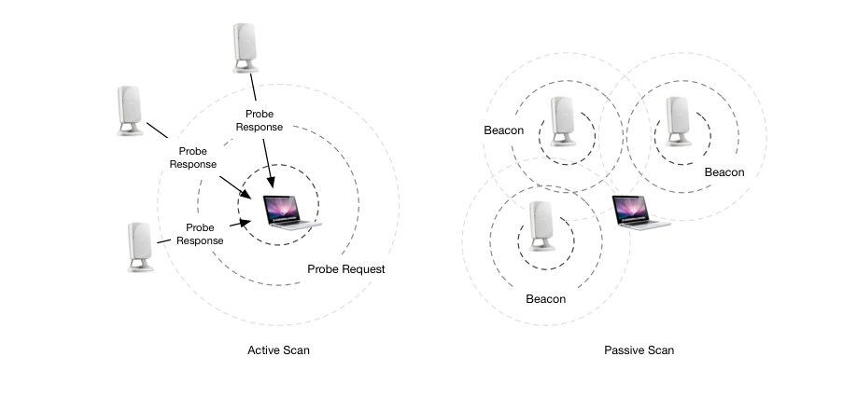

5. Client Association Process
The association process establishes a logical connection between a station (STA) and an Access Point (AP) in three mandatory steps:
Step 1 – Scanning: The station discovers available BSSs through passive or active scanning, collecting SSID, BSSID, supported rates, security capabilities (RSN IE), and channel information.
Step 2 – Authentication: Before associating, the station must authenticate with the AP. In modern WPA2/WPA3 networks this is Open System Authentication (a formality); actual identity verification occurs in the 4-Way Handshake.
- Open System Authentication: Station sends Authentication Request → AP replies with Authentication Response (status = Success). No credentials are exchanged.
- Shared Key Authentication (legacy WEP): Uses a four-way challenge-response based on the WEP key (deprecated and insecure).
Step 3 – Association: The station sends an Association Request frame containing its capabilities (SSID, supported rates, QoS parameters, HT/VHT capabilities, RSN IE with chosen cipher suites). The AP responds with an Association Response. If successful, the AP assigns an Association ID (AID) – a unique 16-bit identifier used to buffer frames during power-saving intervals.
Step 4 – EAPOL 4-Way Handshake (WPA2): Following association, the station and AP perform the 4-Way Handshake to derive and install session encryption keys (detailed in Question 6).
Reassociation: When roaming to a different AP within the same ESS, the station performs Reassociation, allowing the distribution system to transfer state from the old AP to the new one.

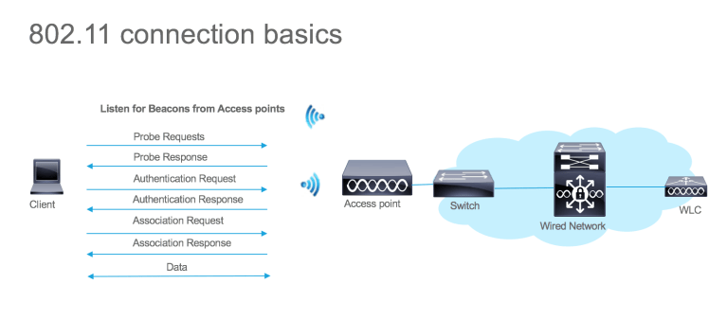

6. EAPOL 4-Way Handshake – Steps and Keys
The EAPOL 4-Way Handshake (defined in IEEE 802.11i / WPA2) mutually authenticates the station and AP and derives session encryption keys. It relies on the Pairwise Master Key (PMK) pre-shared or derived from 802.1X authentication.
Key Hierarchy Before the Handshake:
- PMK (Pairwise Master Key, 256 bits): Derived from PSK or 802.1X EAP authentication. Both station and AP independently compute this value.
- PTK (Pairwise Transient Key): Derived as PTK = PRF(PMK, ANonce, SNonce, AP MAC, STA MAC). Split into KCK, KEK, and TK.
- GTK (Group Temporal Key): Generated by the AP for multicast/broadcast encryption, delivered during the handshake.
The Four Messages:
- Message 1 – AP to STA: The AP sends its ANonce (Authenticator Nonce – a random 256-bit value). The station now has both ANonce and its own SNonce and can compute the PTK.
- Message 2 – STA to AP: The station sends its SNonce and a MIC (Message Integrity Code) computed using KCK. The AP uses SNonce to compute the PTK on its side and verifies the MIC to authenticate the station.
- Message 3 – AP to STA: The AP confirms PTK installation and delivers the encrypted GTK (encrypted with KEK), protected by a MIC. The Install bit signals the station to install the PTK and GTK.
- Message 4 – STA to AP: The station sends an acknowledgment with MIC confirming keys have been installed. The AP then installs its PTK.
Keys Derived from the PTK:
- KCK – Key Confirmation Key (128 bits): Computes the MIC in messages 2 and 3, providing integrity and mutual authentication.
- KEK – Key Encryption Key (128 bits): Used by the AP to encrypt the GTK before delivery to the station in Message 3.
- TK – Temporal Key (128 bits): The actual session encryption key used by CCMP (AES) or TKIP to encrypt and decrypt unicast data frames.
- GTK – Group Temporal Key: Encrypts broadcast and multicast traffic; shared among all stations associated with the AP.
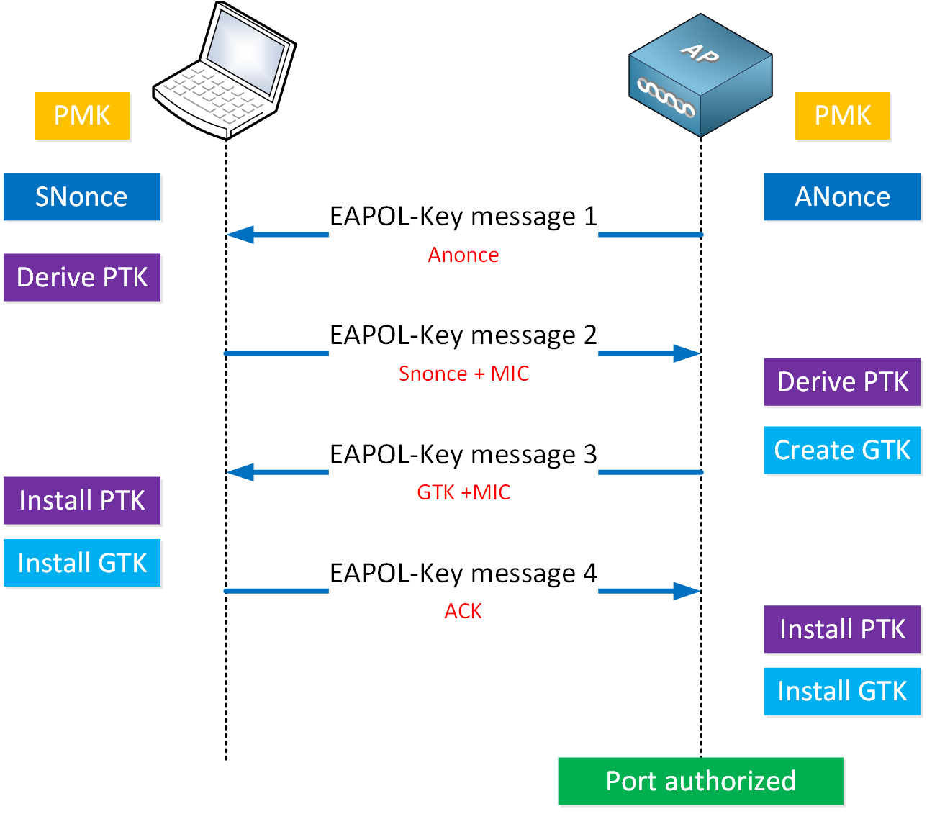

7. Power Saving Scheme in the MAC Layer
IEEE 802.11 defines several power management mechanisms to allow battery-powered stations to enter a low-power sleep state without missing buffered frames.
Legacy Power Save Mode (PSM): A station notifies the AP of its power state via the Power Management bit in the Frame Control field.
- Awake State: Station can transmit and receive normally.
- Doze/Sleep State: Station's radio is powered down; it cannot receive frames.
- TIM (Traffic Indication Map): Included in each Beacon frame indicating which AIDs have buffered unicast frames. If a station's AID appears, it sends a PS-Poll to retrieve each buffered frame.
- DTIM (Delivery Traffic Indication Map): A special TIM transmitted every DTIM interval indicating buffered multicast/broadcast frames. All stations must be awake during a DTIM beacon.
U-APSD – Unscheduled Automatic Power Save Delivery (802.11e): A QoS-aware power saving mechanism where the station triggers frame delivery by sending a QoS Data or QoS Null frame. The AP delivers all buffered frames for that Access Category in a single burst, reducing latency for voice and video while maintaining power savings.
S-APSD (Scheduled APSD): Delivery of buffered frames is scheduled at predetermined intervals negotiated during association, providing deterministic latency for real-time applications.
TWT – Target Wake Time (802.11ax / Wi-Fi 6): Allows the AP to schedule individual wake-up times for each station, dramatically reducing contention and power consumption in dense deployments.
- Individual TWT: Per-station scheduling.
- Broadcast TWT: A group of stations share a scheduled wake time, useful for IoT devices.
WMM Power Save: Wi-Fi Alliance certification of U-APSD, ensuring vendor interoperability for QoS-based power management.

8. Medium Access Control Methodologies
A. DCF – Distributed Coordination Function (CSMA/CA): The fundamental access mechanism for all 802.11 stations. Uses Carrier Sense Multiple Access with Collision Avoidance.
- Physical Carrier Sense: Stations monitor the channel for energy using CCA (Clear Channel Assessment).
- Virtual Carrier Sense (NAV): Stations read the Duration field in received frames and set their Network Allocation Vector, refraining from transmitting while NAV > 0.
- IFS (Interframe Spacing): Mandatory gaps between frames define access priority: SIFS → PIFS → DIFS → EIFS.
- Backoff Procedure: After waiting DIFS, a station chooses a random backoff from [0, CW], decrementing it every idle slot. Transmission begins when the counter reaches zero. On collision, CW doubles (binary exponential backoff).
- RTS/CTS: Optional mechanism where the sender transmits RTS and the receiver replies with CTS, reserving the channel and mitigating hidden node issues.
B. PCF – Point Coordination Function: A centralized, contention-free access method. The AP acts as the Point Coordinator using PIFS to gain priority access, polling stations in sequence during the Contention-Free Period (CFP). Largely superseded by HCCA.
C. EDCA – Enhanced Distributed Channel Access (802.11e): Extends DCF with QoS support through four Access Categories with different AIFSN and CW values:
- AC_VO (Voice): smallest AIFSN and CWmin – highest priority
- AC_VI (Video): moderate priority
- AC_BE (Best Effort): similar to legacy DCF
- AC_BK (Background): largest CW – lowest priority
D. HCCA – HCF Controlled Channel Access (802.11e): A polled, scheduled access mechanism where the Hybrid Coordinator at the AP schedules TXOPs (Transmission Opportunities) for stations, providing deterministic delay and bandwidth guarantees for real-time traffic.
E. OFDMA (802.11ax / Wi-Fi 6): Allows the AP to simultaneously schedule multiple stations on different sub-bands (Resource Units) within a single OFDM symbol period, dramatically improving spectral efficiency in dense environments.

9. Block ACK Mechanism and Its Advantages
The Block Acknowledgment (Block ACK) mechanism allows a station to acknowledge multiple frames with a single Block ACK frame, rather than sending one ACK per frame.
Operation:
- Block ACK Agreement Setup: The initiator sends an ADDBA Request (Add Block ACK) action frame specifying TID, buffer size, and policy (Immediate or Delayed). The recipient responds with ADDBA Response.
- Data Transmission: The initiator transmits a burst of QoS Data frames (possibly as an A-MPDU) within a TXOP, tagged with sequential SSNs.
- Block ACK Request (BAR): After the burst, the initiator sends a BAR frame specifying the starting sequence number of the block.
- Block ACK (BA) Frame: The recipient responds with a BA frame containing a 64-bit bitmap where each bit corresponds to a frame in the sequence window. A '1' indicates successful reception; '0' triggers selective retransmission of that specific frame.
- Teardown: Either party can send a DELBA frame to terminate the Block ACK agreement.
Advantages:
- Reduced Overhead: One ACK for up to 64 frames (802.11n) or 256 frames (802.11ac/ax) drastically reduces the number of control frames.
- Higher Throughput: Eliminating per-frame SIFS + ACK turnaround time significantly increases effective data throughput.
- Efficient Retransmission: The bitmap enables selective retransmission of only lost frames rather than the entire window.
- Lower Latency: Fewer interruptions to the data stream reduce overall transmission latency.
- Essential for Aggregation: Block ACK is the enabling mechanism for A-MPDU aggregation in 802.11n/ac/ax.

10. A-MSDU, A-MPDU, and A-MSDU in A-MPDU
Frame aggregation (introduced in 802.11n) combines multiple data frames into a single PHY transmission to reduce per-frame overhead and improve throughput.
A. A-MSDU – Aggregated MAC Service Data Unit: Combines multiple MSDUs (upper-layer payloads from the same source/destination/TID) into a single MPDU with one MAC header and one FCS.
- Structure: One MAC Header + [MSDU Subframe 1 | MSDU Subframe 2 | ... | MSDU Subframe N] + One FCS. Each subframe has a 14-byte sub-header (DA, SA, Length) with 4-byte boundary padding.
- Maximum Size: 3839 bytes (basic) or 7935 bytes (large A-MSDU in 802.11n/ac).
- Advantages: Significantly reduces MAC/PHY header overhead since only one set of headers is used for multiple payloads.
- Disadvantages: If the A-MSDU is corrupted, all MSDUs must be retransmitted together. Cannot mix frames from different QoS TIDs.
B. A-MPDU – Aggregated MAC Protocol Data Unit: Aggregates multiple complete MPDUs (each with its own MAC header and FCS) into a single PHY transmission (PPDU), separated by MPDU delimiters.
- Structure: [MPDU Delimiter | MPDU 1 (Header + Body + FCS) | Padding] + [MPDU Delimiter | MPDU 2] + ...
- Each delimiter is a 4-byte field containing MPDU length, CRC, and a delimiter signature (0x4E).
- Maximum Size: 65535 bytes (802.11n), up to 1048575 bytes (802.11ac/ax).
- Advantages: Granular error recovery – only the failed MPDU is retransmitted (using Block ACK bitmap). MPDUs can come from different QoS TIDs. Each MPDU has its own FCS for independent integrity checking.
- Requirement: A Block ACK agreement must be established; A-MPDU is inherently linked to Block ACK.
C. A-MSDU in A-MPDU (Two-Level Aggregation): Each MPDU within an A-MPDU can itself carry an A-MSDU as its payload. This two-level aggregation maximizes throughput by reducing both per-payload MAC overhead (A-MSDU) and per-frame PHY overhead (A-MPDU).
- Structure: A-MPDU [ MPDU 1 { A-MSDU [MSDU 1a, MSDU 1b] } | MPDU 2 { A-MSDU [MSDU 2a, MSDU 2b] } | ... ]
- Benefits: Achieves highest possible MAC efficiency – minimal headers per user byte. Mandatory for 802.11ac throughput above 500 Mbps in practice.
- Constraints: All MSDUs within a single A-MSDU must share the same SA, DA, and TID. Total A-MPDU length must not exceed PHY limits.
- Error Handling: If an MPDU (containing an A-MSDU) fails, all MSDUs within that MPDU must be retransmitted together, as the Block ACK bitmap operates at MPDU granularity.
Comparison Summary: A-MSDU reduces per-payload overhead but retransmits all MSDUs on error. A-MPDU provides per-MPDU error recovery and works with Block ACK. Two-level aggregation (A-MSDU in A-MPDU) delivers maximum throughput with block-level error recovery and is the primary aggregation strategy in 802.11ac and 802.11ax networks.

